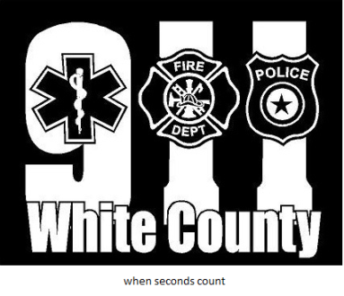
Enroll Now Free
Text “WCALERTS” to 24639
OR
Scan the code below!
Receive emergency alerts regarding YOUR area
- Extreme danger alerts
- Evacuation orders
- Severe weather events
- Law enforcement warnings
- Emergency road closures
- Burn ban notifications
- Any and all other emergencies
Available in SMS text, email, and voice call. Alerts beginning October 2023
https://accountportal.onsolve.net/whitecountyalerts Call (501)279-6277 for assistance

